Corelap Algorithm for Layout Design

A Relationship (REL) Chart represents M (M-1)/2 symmetric qualitative relationships each representing the degree of closeness desired between two departments in the layout. (See figure)
r
12
r
13
r
23

Here,

M= no. of Stations
rij ∈{A, E, I, O, U,X} is Closeness Value (CV) between activities i and j;
rij is an ordinal value.

A number of factors other than material handling flow (cost) might be of primary concern in layout design.

rij values when comparing pairs of activities:

A = absolutely necessary
E = especially important
I = important
O = ordinary closeness
U = unimportant
X = undesirable

V (rij) = arbitrary cardinal value assigned to rij, e.g., V (U) = 0, etc.

Adjacency

- Two activities are (fully) adjacent in a layout if they share a common border of positive length, i.e., not just a point.

- Two activities are partially adjacent in a layout if they only share one or a finite number of points, i.e., zero length.

- Let aij ∈ [0, 1]: adjacency coefficient between activities i and j.

3
1
2
4
5
- Example:
3
1
2
4
5

(Fully) adjacent: a12 = a13 = a24 = a34 = a45 = 1,

Partially adjacent: a14 = a23 = a25 =α, and

Non-adjacent: a15 = a25 = 0.

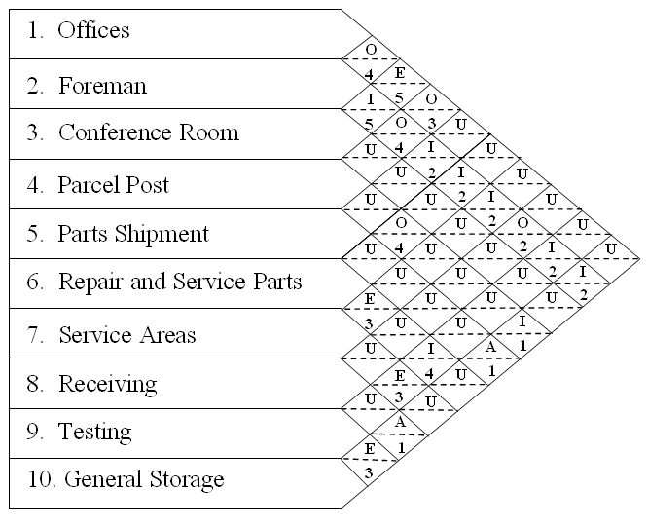
Code Reason

Code Reason

1 Flow of material
2 Ease of supervision
3 Common personnel
4 Contact Necessary
5 Conveniences

Rating Definition
A Absolutely Necessary
E Especially Important
I Important
O Ordinary Closeness OK
U Unimportant
X Undesirable

Manual CORELAP Algorithm

- CORELAP is a construction algorithm to create a block layout from a REL chart.

- Each department (activity) is represented by a unit square.

- Numerical values are assigned to CV’s:

V (A) = 10,000, V (O) = 10,
V (E) = 1,000, V (U) = 0,
V (I) = 100, V(X) = -10,000.

- For each department, the Total Closeness Rating (TCR) is the sum of the absolute values of the relationships with other departments.

For above given data, the TCRs are calculated as below:

TCR CHART

 | 1 | 2 | 3 | 4 | 5 | 6 | 7 | 8 | 9 | TCR
1 | - | A | A | E | O | U | U | A | O | 31020
2 | A | - | E | A | U | O | U | E | U | 22010
3 | A | E | - | E | A | U | U | E | A | -32536
4 | E | A | E | - | E | O | A | E | U | 24010
5 | O | U | A | E | - | A | A | O | A | -24516
6 | U | O | U | O | A | - | A | O | O | 20040
7 | U | U | U | A | A | A | - | X | A | 30000
8 | A | E | E | E | O | O | X | - | X | -6980
9 | O | U | A | U | A | O | A | X | - | 20020

Procedure to Select Departments

- The first department placed in the layout is the one with the greatest TCR value. If a tie exists, choose the one with more A’s.
- If a department has an X relationship with the first one, it is placed last in the layout. If a tie exists, choose the one with the smallest TCR value.
- The second department is the one with an A relationship with the first one. If a tie exists, choose the one with the greatest TCR value.
- If a department has an X relationship with he second one, it is placed next-to-the-last or last in the layout. If a tie exists, choose the one with the smallest TCR value.
- The third department is the one with an A relationship with one of the placed departments. If a tie exists, choose the one with the greatest TCR value.
- The procedure continues until all departments have been placed.

Procedure to Place Departments

- Consider the figure on the right. Assume that a department is placed in the middle (position 0). Then, if another department is placed in position 1, 3, 5 or 7, it is “fully adjacent” with the first one. It is placed in position 2, 4, 6 or 8, it is “partially adjacent”.
8
7
6
5
4
3
2
1
0

- For each position, Weighted Placement Value (WPV) is the weighed sum of the closeness values for all pairs of adjacent departments.

- The weighed sum means that for fully adjacent departments, closeness value is added as it is and for partially adjacent departments, half the closeness value is added to get the WPV.

- For example consider the following stage in which two departments 5 and 7 have already been placed and the placement of next department say 6 is under consideration which is having A (closeness value=10000) relationship with 5 and E (closeness value=1000) relationship with 7, then the WPVs for possible neighboring positions are:

7
1000
5000
500
500
10500
5
10000
5000
6000
10500
6000

- The placement of departments is based on the following steps:

- The first department selected is placed in the middle.
- The placement of a department is determined by evaluating all possible locations around the current layout in counterclockwise order beginning at the “western edge”.
- The new department is located based on the greatest WPV.

For example in the above considered case, department 6 should be placed just below 5 because of the first encounter of highest WPV 10500 starting anticlockwise from the position just left of 5 (western edge).

PROBLEM GIVEN IN PRACTICAL

The number of departments is 16. The REL chart is:

 | 1 | U | O | A | X | U | A | X | I | U | E | I | U | U | X | U
 |  | 2 | O | U | E | E | U | O | O | U | E | I | U | I | X | O
 |  |  | 3 | U | I | U | U | O | U | U | U | O | U | O | O | O
 |  |  |  | 4 | U | E | E | O | U | U | U | U | U | U | U | U
 |  |  |  |  | 5 | I | U | E | I | U | O | O | U | I | O | O
 |  |  |  |  |  | 6 | U | I | U | U | U | U | U | U | U | U
 |  |  |  |  |  |  | 7 | O | U | U | U | U | U | U | U | U
 |  |  |  |  |  |  |  | 8 | U | I | I | E | A | U | I | I
 |  |  |  |  |  |  |  |  | 9 | U | A | U | U | U | U | U
 |  |  |  |  |  |  |  |  |  | 10 | U | U | A | U | U | U
 |  |  |  |  |  |  |  |  |  |  | 11 | U | U | U | U | U
 |  |  |  |  |  |  |  |  |  |  |  | 12 | U | U | U | U
 |  |  |  |  |  |  |  |  |  |  |  |  | 13 | U | U | U
 |  |  |  |  |  |  |  |  |  |  |  |  |  | 14 | U | O
 |  |  |  |  |  |  |  |  |  |  |  |  |  |  | 15 | I
 |  |  |  |  |  |  |  |  |  |  |  |  |  |  |  | 16

Here the Stations and their respective areas are:

Sr. No. Department Area

1 Foundry 2000
2 Press 3000
3 Drill 1000
4 Grind 500
5 Machine 3000
6 Weld 500
7 Mill 500
8 Assemble 4000
9 Receiving 2000
10 Shipping 3000
11 R M Storage 2500
12 WIP Storage 2000
13 F G Storage 3000
14 Maintenance 500
15 Offices 2000
16 Locker Room 1000

TCR CHART

123456789101101213141516TCR

1-UOAXUAXIUEIUUXU-8790
2U-OUEEUOOUEIUIXO-6760
3OO-UIUUOUUUOUOOO170
4AUU-UEEOUUUUUUUU12010
5XEIU-IUEIUOOUIOO-7560
6UEUEI-UIUUUUUUUU2200
7AUUEUU-OUUUUUUUU11010
8XOOOEIO-UIIEAUII2540
9IOUUIUUU-UAUUUUU10210
10UUUUUUUIU-UUAUUU10100
11EEUUOUUIAU-UUUUU12110
12IIOUOUUEUUU-UUUU1220
13UUUUUUUAUAUU-UUU20000
14UIOUIUUUUUUUU-UO220
15XXOUOUUIUUUUUU-I-19780
16UOOUOUUIUUUUUOI-240

SELECTION AND PLACEMENT OF STATIONS

Based on the CORELAP technique, following is the order and position of Stations to be placed. Here position is referred in terms of (row, column). The row index is increasing in downward direction from top and the column index increasing rightwards from left. The first Station (13) has been placed arbitrarily at position (21, 21) and the position of the subsequent Stations is thus respect to it.

ORDER STATION POSITION (row, column)

1 Station : 13 at 21 , 21
2 Station : 10 at 21 , 20
3 Station : 8 at 22 , 21
4 Station : 12 at 22 , 20
5 Station : 5 at 23 , 21
6 Station : 2 at 23 , 20
7 Station : 11 at 24 , 20
8 Station : 9 at 24 , 21
9 Station : 6 at 23 , 19
10 Station : 4 at 22 , 19
11 Station : 7 at 21 , 19
12 Station : 16 at 22 , 22
13 Station : 14 at 23 , 22
14 Station : 3 at 24 , 22
15 Station : 15 at 21 , 22
16 Station : 1 at 21 , 18

The layout thus is:

1 | 7 | 10 | 13 | 15
 | 4 | 12 | 8 | 16
 | 6 | 2 | 5 | 14
 |  | 11 | 9 | 3

ACTUAL BLOCK LAYOUTS FROM DESIGNED INITIAL LAYOUT

Based on the above derived initial layout, this can be done keeping in view the areas of various stations and the shape of the total area available in which layout has to be fitted.

The station wise areas available are scaled down to smaller values and then the layout is designed for 3 basic shapes, a rectangle, a square and u shape:

SCALED DOWN STATION AREAS

SATION AREA AREA IN SCALED DOWN UNITS
1 Foundry 2000 4
2 Press 3000 6
3 Drill 1000 2
4 Grind 500 1
5 Machine 3000 6
6 Weld 500 1
7 Mill 500 1
8 Assemble 4000 8
9 Receiving 2000 4
10 Shipping 3000 6
11 R M Storage 2500 5
12 WIP Storage 2000 4
13 F G Storage 3000 6
14 Maintenance 500 1
15 Offices 2000 4
16 Locker Room 1000 2
TOTAL 30500 61

One scaled down unit = 500 area units

NOTE: Slight modifications in the above mentioned areas are allowed to fit the stations in considered shape area optimally.

1. RECTANGULAR AREA:
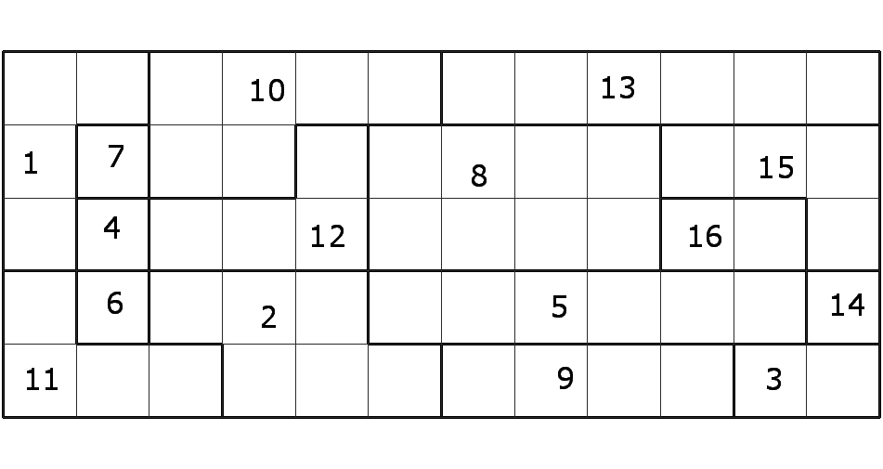

2. SQUARE AREA:

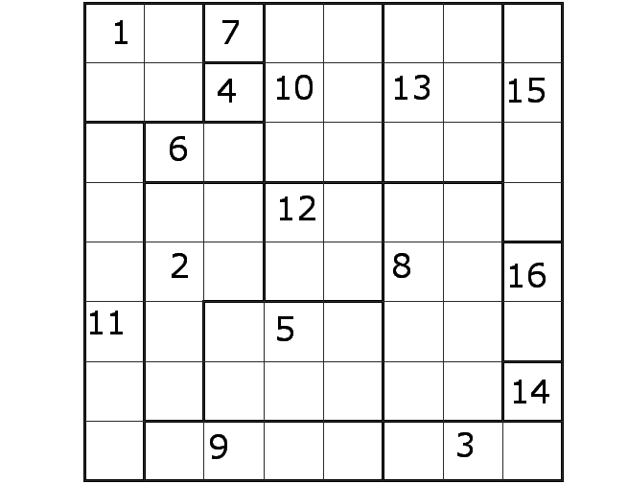

3. U SHAPE AREA

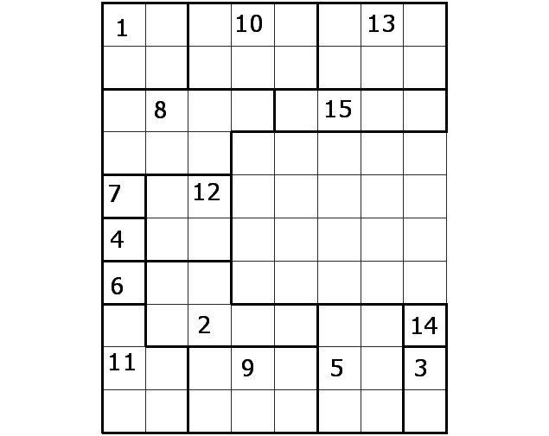

COMPUTER PROGRAM IN C PROGRAMMING LANGUAGE FOR CORELAP TECHNIQUE

To run the program, the following code is to be compiled using a C-compiler and the caylplan.exe file thus generated has to be saved in a folder named CALYPLAN in C drive only i.e. the path of exe file should be C:\calyplan\calyplan.exe

// PROGRAM NAME: CALYPLAN

#include<conio.h>
#include<stdio.h>
#include<iostream.h>
#include<process.h>
#include"graphics.cpp"

#define SZ 42

#define AVALUE 10000
#define EVALUE 1000
#define IVALUE 100
#define OVALUE 10
#define UVALUE 0
#define XVALUE -10000

int indexmax ( int [] , int );
void establish_neb ( int [][SZ], int [][SZ] );
void establish_neborder ( int [][SZ], int [][2],int );
void establish_reltab ( int, int [], char [][SZ],int [][SZ][SZ]);
int establish_nextstation( int,int [][SZ][SZ],int [],int [],int,int[]);
int fill_last ( char [][SZ],int,int [],int,int [],int [],int);
void establish_wpvgrid ( int [][SZ], int,char [][SZ], int [][SZ],int [][SZ]);
int value ( char );
void establish_xy ( int [][SZ],int [][2], int [][SZ],int [][SZ],int []);
void establish_inputmatrix( int);

void main()
{
char input[SZ][SZ];
int tcr[SZ],status[SZ][SZ],neb[SZ][SZ],neborder[1000][2],wpv[SZ][SZ],
reltab[6][SZ][SZ],station[SZ],stnsta[SZ],last[SZ],layout[SZ][SZ],xy[2];
int n,i,j,k,nextstni,midx,midy,x,y,noflast,leftovers;
FILE *fp;
clrscr();
midx=SZ/2; midy=SZ/2;
///////////////////////////// input //////////////////////////////////

cout<<"\n\n\n\n C A L Y P L A N\n\n";
bhline();
cout<<"\n\n Computer Aided Layout Planning ";
gotoxy(23,20);
cout<<"Press any key to continue...";
getch();

clrscr();
cout<<"CALYPLAN\n";
hline();
cout<<"\n\nReading data from input.txt\n\nEnter no. of stations : ";
cin>>n;

establish_inputmatrix(n);
//exit(0);
fp=fopen("C:\\CALYPLAN\\calyplan.txt","r");

for(i=0;i<n;i++)
{
for(j=0;j<n;j++)
{
fscanf(fp," %c",&input[i][j]);
}
fscanf(fp,"%d\n",&tcr[i]);
}
fclose(fp);
///////////////////////////// initialisation //////////////////////////////////
for(i=0;i<SZ;i++)
{
for(j=0;j<SZ;j++)
{
status[i][j]=0;
neb [i][j]=0;
wpv [i][j]=0;
layout[i][j]=0;
}
}

for(i=0;i<6;i++)
{
for(j=0;j<SZ;j++)
{
for(k=0;k<SZ;k++)
{
reltab[i][j][k]=0;
}
}
}
for(i=0;i<n;i++)
{
station[i]=i+1;
last [i]=0;
stnsta [i]=0;
}

xy[0]=xy[1]=0;
leftovers=0;
/////////////////////////// 1st station placement //////////////////////////
nextstni=indexmax(tcr,n);
noflast=0;
noflast=fill_last(input,nextstni,last,n,tcr,stnsta,noflast);

x=midx; y=midy;
layout[x][y]=station[nextstni];
status[x][y]=1;
stnsta[station[nextstni]-1]=1;

cout<<"\n1\tstation : "<<station[nextstni]<<"\tat "<<x<<" , "<<y;//<<"\tlast : "<<last[0]<<","<<last[1];
writescreen("C:\\CALYPLAN\\calytemp.txt");
/////////////////////////// rest placements //////////////////////////
for(i=1;i<n;i++)
{
if( (i+noflast)==n ) { leftovers=1; /*cout<<" M "<<i<<" "<<noflast;*/ }
if(!leftovers)
{
establish_neb (status,neb);
establish_neborder (neb,neborder,midx);
establish_reltab (n,stnsta,input,reltab);
nextstni=establish_nextstation (n,reltab,tcr,last,noflast,stnsta);
noflast =fill_last (input,nextstni,last,n,tcr,stnsta,noflast);
establish_wpvgrid (wpv,nextstni,input,status,layout);
establish_xy (neb,neborder,wpv,status,xy);

x=xy[0]; y=xy[1];
layout[x][y]=station[nextstni];
status[x][y]=1;
neb[x][y]=0;
stnsta[station[nextstni]-1]=1;

for(j=0;j<SZ;j++)
for(k=0;k<SZ;k++)
wpv[j][k]=0;
}

if(leftovers)
{
establish_neb (status,neb);
establish_neborder (neb,neborder,midx);

nextstni=last[noflast-1];

establish_wpvgrid (wpv,nextstni,input,status,layout);
establish_xy (neb,neborder,wpv,status,xy);

x=xy[0]; y=xy[1];
layout[x][y]=station[nextstni];
status[x][y]=1;
neb[x][y]=0;
stnsta[station[nextstni]-1]=1;

for(j=0;j<SZ;j++)
for(k=0;k<SZ;k++)
wpv[j][k]=0;

noflast--;
}
cout<<"\n"<<i+1<<"\tstation : "<<station[nextstni]<<"\tat "<<x<<" , "<<y;//<<"\tlast : "<<last[0]<<","<<last[1]<<" , "<<noflast;
writescreen("C:\\CALYPLAN\\calytemp.txt");
}
///////////////// all placements over ////////////////////////////////////
fp=fopen("C:\\CALYPLAN\\calyplan.txt","a");
for(i=0;i<SZ;i++)
{
for(j=0;j<SZ;j++)
{
if(!layout[i][j]) fprintf(fp," ");
else fprintf(fp,"%-4d",layout[i][j]);
}
fprintf(fp,"\n");
}
fclose(fp);
cout<<"\n\nOutput saved in file calyplan.txt\nIntermediate status saved in file calytemp.txt\n\nPress any key to exit...";
writescreen("C:\\CALYPLAN\\calytemp.txt");
getch();
cbab();
}
/*************************************************************************/
int indexmax(int a[],int n)
{
int m=0;
for (int i=1;i<n;i++)
if (a[i]>a[m]) m=i;
return m;
}
/*************************************************************************/
void establish_neb ( int st[][SZ], int nb[][SZ] )
{
int i,j;

for(i=1;i<SZ-1;i++)
{
for(j=1;j<SZ-1;j++)
{
if(st[i][j]) ;
else
if( st[i-1][j-1] || st[i-1][j] || st[i-1][j+1] ||
st[i ][j-1] || st[i ][j+1] ||
st[i+1][j-1] || st[i+1][j] || st[i+1][j+1] )
nb[i][j]=1;
}
}

return;
}
/*************************************************************************/
void establish_neborder ( int nb[][SZ], int nbo[][2], int mx )
{
int i,j,x,y,stx,sty,nofneb=0, nbdone[SZ][SZ];

for(i=0;i<SZ;i++)
for(j=0;j<SZ;j++)
nbdone[i][j]=0;

for(i=0;i<SZ;i++)
for(j=0;j<SZ;j++)
if(nb[i][j]) nofneb++;

for(j=1;j<SZ;j++)
{
if(nb[mx][j-1] && (!nb[mx][j]) )
{ stx=mx; sty=j-1; break; }
}

nbo[0][0]=stx; nbo[0][1]=sty; nb[stx][sty]=1;
x=stx; y=sty;

for(i=1;i<=nofneb-1;i++)
{
if(nb[x][y-1] && !nbdone[x][y-1] )
{ x=x; y=y-1; nbo[i][0]=x; nbo[i][1]=y; nbdone[x][y]=1; continue; }

if(nb[x+1][y] && !nbdone[x+1][y] )
{ x=x+1; y=y; nbo[i][0]=x; nbo[i][1]=y; nbdone[x][y]=1; continue; }

if(nb[x][y+1] && !nbdone[x][y+1] )
{ x=x; y=y+1; nbo[i][0]=x; nbo[i][1]=y; nbdone[x][y]=1; continue; }

if(nb[x-1][y] && !nbdone[x-1][y] )
{ x=x-1; y=y; nbo[i][0]=x; nbo[i][1]=y; nbdone[x][y]=1; continue; }
}

return;
}
/**************************************************************************/
void establish_reltab
( int n, int stnsta[], char input[][SZ],int reltab[][SZ][SZ])
{
int i,j,nop,placedstns[SZ];
char relation;

for(i=0,j=0;i<n;i++)
{ if(stnsta[i]) placedstns[j++]=i; }
nop=j;

for(i=0; i<nop; i++)
{
for(j=0;j<n;j++)
{
relation=input[placedstns[i]][j];
switch(relation)
{
case 'a':
case 'A':
reltab[0][placedstns[i]][j]=1;
break;
case 'e':
case 'E':
reltab[1][placedstns[i]][j]=1;
break;
case 'i':
case 'I':
reltab[2][placedstns[i]][j]=1;
break;
case 'o':
case 'O':
reltab[3][placedstns[i]][j]=1;
break;
case 'u':
case 'U':
reltab[4][placedstns[i]][j]=1;
break;
case 'x':
case 'X':
reltab[5][placedstns[i]][j]=1;
break;
case '-':
break;
default:
cout<<"\nUnidentified character '"<<relation<<"'found in input table.\n\nPress any key to terminate program...";
getch();
exit(0);
break;
}
}
}
return;
}
/*************************************************************************/
int establish_nextstation( int n,int reltab[][SZ][SZ],int tcr[],int last[],
int noflast, int stnsta[])
{
int i,j,k,p,t[SZ],tc[SZ],m=0,flag=0,notinlast=1;

for(i=0;i<6;i++)
{
for(j=0;j<n;j++)
{
for(k=0;k<n;k++)
{
for(p=0;p<noflast;p++)
{
if (k==last[p]) { notinlast=0; break; }
}
// cout<<"\n "<<i<<" "<<j<<" "<<k<<" "<<reltab[i][j][k]; //////
if(reltab[i][j][k] && (!stnsta[k]) && notinlast)
{ t[m++]=k; flag=1; }
else notinlast=1;
}
}
//getch(); /////////
if(flag) break;
}

for(j=0;j<m;j++)
{ //cout<<" "<<tcr[j]<<","; //////////
tc[j]=tcr[t[j]];
}

//getch(); ///////
//exit(0); ////////
return (t[indexmax(tc,m)]);
}

/*************************************************************************/
int fill_last ( char input [][SZ],int nextstni,int last[], int n, int tcr[],
int stnsta [], int nofl)
{
int i,j,k,t[SZ],tc[SZ],m=0,atleast1found=0,alreadypresentinlast=0,
alreadyplaced=0;

for(k=0;k<n;k++)
{
if(input[nextstni][k] == 'x' || input[nextstni][k]=='X' )
{
for(i=0;i<nofl;i++)
{
if (last[i]==k)
{ alreadypresentinlast=1; break; }
}

if(stnsta[k]) alreadyplaced=1;

if(!alreadypresentinlast && !alreadyplaced)
{
t[m++]=k;
atleast1found=1;
alreadypresentinlast=0;
alreadyplaced=0;
// cout<<"k";
}
}
}

if(atleast1found)
{
for(j=0;j<m;j++) { tc[j]=-1*tcr[j]; }
i= t[indexmax(tc,m)];
last[nofl]=i;
return (nofl+1);
}
else return (nofl);
}

/*************************************************************************/
void establish_wpvgrid ( int wpv[][SZ], int nextstni,char input[][SZ],
int status [][SZ], int layout [][SZ] )
{
int i,j,k;

for(i=0;i<SZ;i++)
{
for(j=0;j<SZ;j++)
{
if(status[i][j])
{ wpv[i][j]=value(input[nextstni][layout[i][j]-1]); }
}
}

return;
}

/*************************************************************************/
int value (char ch)
{
int t;
switch (ch)
{
case 'a':
case 'A':
//t=10000;
t=AVALUE;
break;

case 'e':
case 'E':
//t=1000;
t=EVALUE;
break;

case 'i':
case 'I':
//t=100;
t=IVALUE;
break;

case 'o':
case 'O':
//t=10;
t=OVALUE;
break;

case 'u':
case 'U':
//t=0;
t=UVALUE;
break;

case 'x':
case 'X':
//t=-10000;
t=XVALUE;
break;

}
return t;
}

/*************************************************************************/
void establish_xy ( int nb[][SZ],int neborder[][2], int wpv[][SZ],
int st[][SZ],int xy[])
{
int i,j,k,nofneb=0,tm,t[SZ],m=0;

for(i=0;i<SZ;i++)
for(j=0;j<SZ;j++)
if(nb[i][j]) nofneb++;

for(k=0;k<nofneb;k++)
{
xy[0]=neborder[k][0]; xy[1]=neborder[k][1];
tm=0;
//cout<<" "<<xy[0]<<"XY"<<xy[1]<<"-";
i=xy[0]; j=xy[1];

if(st[i-1][j ]) { tm+=wpv[i-1][j ]; }
if(st[i ][j-1]) { tm+=wpv[i ][j-1]; }
if(st[i ][j+1]) { tm+=wpv[i ][j+1]; }
if(st[i+1][j ]) { tm+=wpv[i+1][j ]; }

if(st[i-1][j-1]) { tm+=wpv[i-1][j-1]/2; }
if(st[i-1][j+1]) { tm+=wpv[i-1][j+1]/2; }
if(st[i+1][j-1]) { tm+=wpv[i+1][j-1]/2; }
if(st[i+1][j+1]) { tm+=wpv[i+1][j+1]/2; }

t[m++]=tm; //cout<<"_";
}

//cout<<endl; for(i=0;i<m;i++) { cout<<" w"<<t[i]; } cout<<endl; getch();

xy[0]=neborder[indexmax(t,m)][0];
xy[1]=neborder[indexmax(t,m)][1];

return;
}
/**************************************************************************/
void establish_inputmatrix( int n)
{
FILE *fp1,*fp2;
char tab[SZ][SZ],tabt[SZ][SZ];
int i,j,k,i1,j1;

fp1=fopen("C:\\CALYPLAN\\input.txt","r");
fp2=fopen("C:\\CALYPLAN\\temp.txt","w");

if(fp1==NULL) { cout<<"\n\n Input file input.txt not found !\n\n\nPress any key to exit..."; getch(); exit(0); }

for(i=0;i<n-1;i++)
{
for(j=0;j<n-1;j++)
{
if(j<i) tab[i][j]=' ';
else
fscanf(fp1," %c",&tab[i][j]);
}
}

for(i=0;i<n-1;i++)
{
for(j=0;j<n-1;j++)
{
tabt[i][j]=tab[j][i];
}
}

for(i=0;i<n;i++)
{
for(j=0,j1=0;j<n;j++)
{
if (j<i && i>0) fprintf(fp2,"%c\t",tabt[i-1][j1++]);
else if (j>i) fprintf(fp2,"%c\t",tab[i][j1++]);
else fprintf(fp2,"-\t");
}
fprintf(fp2,"\n");
}

fclose(fp1);
fclose(fp2);

fp2=fopen("C:\\CALYPLAN\\temp.txt","r");

int na,ne,ni,no,nu,nx,tcr[SZ];
char ch;

for(i=0;i<n;i++)
{ tcr[i]= 0; }

for(i=0;i<n;i++)
{
na=ne=ni=no=nu=nx=0;

for(j=0;j<n;j++)
{
fscanf(fp2," %c",&ch);
switch(ch)
{
case 'a':
case 'A':
na++;
break;

case 'e':
case 'E':
ne++;
break;

case 'i':
case 'I':
ni++;
break;

case 'o':
case 'O':
no++;
break;

case 'u':
case 'U':
nu++;
break;

case 'x':
case 'X':
nx++;
break;
default:
;
}
}
tcr[i]=na*value('a')+
ne*value('e')+
ni*value('i')+
no*value('o')+
nu*value('u')+
nx*value('x');
//cout<<endl<<tcr[i]; getch();
fscanf(fp2,"\n");
}

fclose(fp2);
fp1=fopen("C:\\CALYPLAN\\temp.txt","r");
fp2=fopen("C:\\CALYPLAN\\calyplan.txt","w");

for(i=0;i<n;i++)
{
for(j=0;j<n;j++)
{
fscanf(fp1," %c",&ch);
fprintf(fp2,"%c\t",ch);
}
fprintf(fp2,"%d\n",tcr[i]);
fscanf(fp1,"\n");
}
fclose(fp1);
fclose(fp2);
//remove("C:\\CALYPLAN\\calyplan.txt");
//rename("C:\\CALYPLAN\\temp.txt","C:\\CAYPLAN\\calyplan.txt");

return;
}
/******************* end of program **********************************/

